Application Code (ota_img_1)

**Relevant Path and Important Code Changes:**

1.Loader/Linker Script Path

*<Refer below snippet for changes in xxx.ld file; verify the address and length>*

T:\OTA_UPDATE\OTA_demo\ota_img_1_src\FreeRTOS\vendors\st\boards\stm32l475_discovery\aws_demos\STM32L475VGTx_FLASH.ld

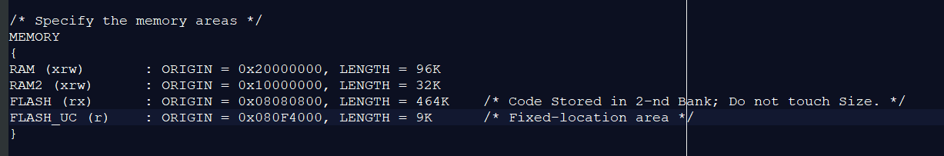

2.iot_config.h

*<add the pre-signed URLS to this file>*

*<Generate URL for the version-file;Not the aws_demo.bin file; in this case* ***test_firmware.txt*** *is my version file >*

*<* command for 7-days URL: ***aws s3 presign s3://firmware-stm/test_firmware.txt --expires-in 604800****>*

T:\OTA_UPDATE\OTA_demo\ota_img_1_src\FreeRTOS\vendors\st\boards\stm32l475_discovery\aws_demos\config_files\iot_config.h

3.aws_clientcredential.h

*<Edit this file for your wifi-credentials>*

T:\OTA_UPDATE\OTA_demo\ota_img_1_src\FreeRTOS\demos\include\aws_clientcredential.h

4.aws_clientcredential_keys.h

*<This file is generated via quick connect, no changes in this file>*

T:\OTA_UPDATE\OTA_demo\ota_img_1_src\FreeRTOS\demos\include\aws_clientcredential_keys.h

5. system_stm32l4xx.c

*<Vector Table Relocation ;Vector Offset>*

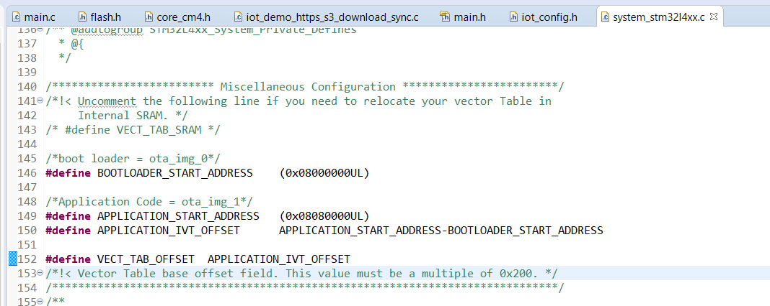

T:\OTA_UPDATE\OTA_demo\ota_img_1_src\FreeRTOS\vendors\st\stm32l475_discovery\CMSIS\system_stm32l4xx.c

OTA_Bootloader (ota_img_0)

**Path and Changes:**

1.Loader/Linker Script Path

*<Refer below snippet for changes in xxx.ld file; verify the address and length>*

T:\OTA_UPDATE\OTA_demo\ota_img_0_src\FreeRTOS\vendors\st\boards\stm32l475_discovery\aws_demos\STM32L475VGTx_FLASH.ld

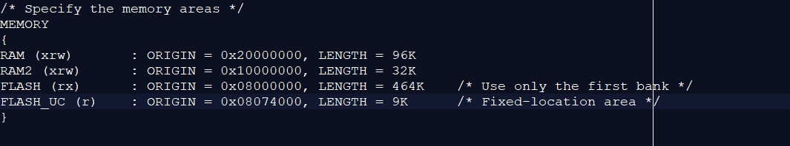

2.iot_config.h

*<add the pre-signed URLS to this file>*

*<Generate URL for aws_demo.bin file>*

*<* command for 7-days URL: ***aws s3 presign s3://firmware-stm/aws_demos.bin --expires-in 604800****>*

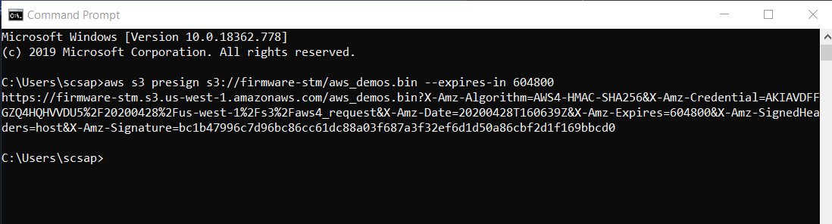

T:\OTA_UPDATE\OTA_demo\ota_img_0_src\FreeRTOS\vendors\st\boards\stm32l475_discovery\aws_demos\config_files\iot_config.h

3.aws_clientcredential.h

*<Edit this file for your wifi-credentials>*

T:\OTA_UPDATE\OTA_demo\ota_img_0_src\FreeRTOS\demos\include\aws_clientcredential.h

4.aws_clientcredential_keys.h

*<This file is generated via quick connect, no changes in this file>*

T:\OTA_UPDATE\OTA_demo\ota_img_0_src\FreeRTOS\demos\include\aws_clientcredential_keys.h

Flash Memory Organisation

